The Homestead at Carrollton Homeowners Association, Inc.
3917 Windmill Trail, Carrollton, TX 75007
November 7, 2023
7:00 pm

Board Meeting Minutes
Board Members Present: Roy Atwood, Shari Pallant, Shawn Faghihifar, Andrew Avalos
Others in Attendance. Melissa Chestnut-First Service Residential, Patty Cash-HOA Admin via zoom

Actions by the Board of Directors. The following actions were approved/opposed by the Board of Directors:
Andrew motioned the September 26,2023 Board Minutes be approved. Shawn 2nd. All in favor.
Andrew motioned to accept the Bank Analysis recommendation for the Reserve Account. Shari 2nd. All in favor.
Roy motioned to table this discussion for now due to the cost of the lights. Shari 2nd. All in favor.
Andrew motioned to spend up to $2500 for a single bottle filling drinking fountain and wall repair. Shawn 2nd. All in favor.
Andrew motioned to approve the fining policy as presented by Riddle and Williams. Shawn 2nd. All in favor.
Roy adjourned the meeting at 7:36 pm.
Ratified actions by the Board of Directors. The following actions were approved/opposed by the Board
The Board approved a payment plan for account L0277-0000-0076-04 via email.
Meeting Discussion
The meeting was called to order at 7:00 PM by Roy Atwood. Quorum has been met.
Andrew motioned the September 27,2023 Board Minutes be approved. Shawn 2nd. All in favor.
Committee Reports:
ACC –Shawn reported the number of requests since September 2023. ACC has been keeping up with the requests.
Landscaping: Roy reported he approved the bushes in front of the clubhouse be replaced since they have died due to the hot summer. Also approved was cutting the bushes on the west side of the pool area next to 1824 Morning Glory. The homeowner is selling the house, and the inspector recommended the bushes be cut back so not to hang over on the patio arbor.
Communications: Roy reported the newsletter articles are due at the end of this month.
HOA Admin: Patty asked the Board if they would be interested in a Halloween Decorating contest for the neighborhood. Andrew filled in details by stating we could do a Halloween and a Christmas decorating contest. Homeowners would have to register and there would be a small cash prize. This will be discussed in further detail next year.
Dan Huntley has asked if he can advertise in our newsletter. The Board discussed different options. For now, a thank you with Dan’s info will be placed in the newsletter until Melissa finds out about having homeowners pay for ads in our newsletter.
Financial Report: Andrew reported everything is close to budget for the year. The water bill is slightly lower now with the cooler temperatures. It has been a quiet month, and everything is looking good for the year.
- Reserved Fund Balance: Melissa notified the Board that in reviewing the Association financials, she noticed the reserve account balance exceeds the $250K insured by the FDIC. She reached out to the financial department to see what recommendations they can provide the BOD for consideration. The financial department recommended putting the excess into money market and cd accounts.
Andrew motioned to accept the Bank Analysis recommendation for the Reserve Account. Shari 2nd. All in favor.
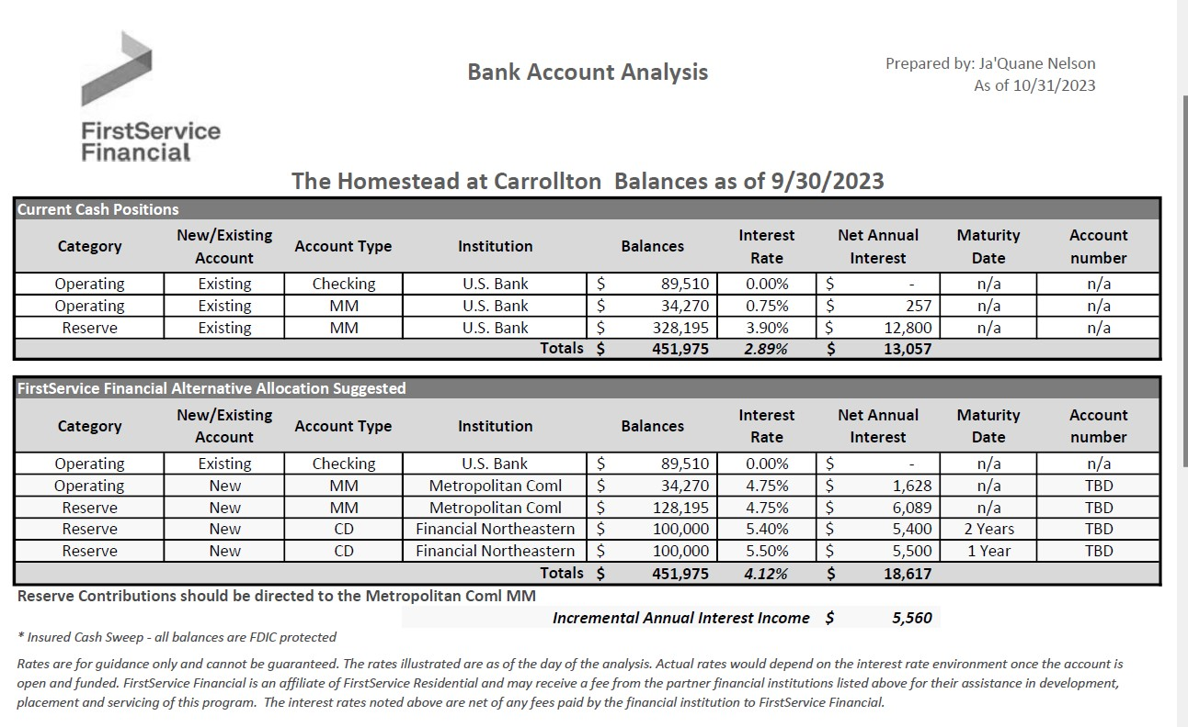

Business Items:
Primrose Gazebo Lighting: Roy motioned to table this discussion for now due to the cost of the lights. Shari 2nd. All in favor.
Replacement Water Fountain: Two proposals were presented to the Board. Andrew stated the bottle filling option would be more beneficial to residents. Discussion to decide if one or two water fountains are needed.
Andrew motioned to spend up to $2500 for a single bottle filling drinking fountain and wall repair to be paid out of the operating expenses. Shawn 2nd. All in favor.
Handrails: The Board decided on the design for the previously approved handrail. Melissa will notify Tamrack of the decision.
Enforcement and Fining Policy: Discussion regarding the fining policy as required by the Texas legislative. Andrew motioned to approve the fining policy as presented by Riddle and Williams. Shawn 2nd. All in favor.
Roy adjourned the meeting at 7:36 pm.

