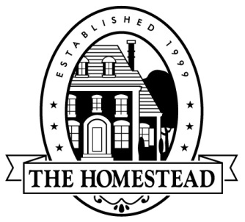

The Homestead at Carrollton
3102 Oak Lawn Ave Suite 202 Dallas, TX 75219
telephone (877) 378-2388 facsimile (214) 889-9980

2017 Annual Meeting Minutes
March 20, 2017
Attendees:
Board Members: Neil Anson, President; Roy Atwood, Secretary; Ed Skelton, Treasurer; Ty Albright, Director; Steve Kerper, Director
FirstService Residential: Barbara Thomas, Association Manager; Diane Albright, HOA Admin.
Meeting was called to order at 7:24PM by President, Neil Anson and quorum was established.
In accordance with the Bylaws, Notice of the Meeting was mailed to all owners of record on February 20, 2017.
2016 Annual Meeting minutes were presented and correction in spelling noted for Rusty Nejdl. A motion was made by Terri Humphries to approve the 2016 Annual Meeting minutes as corrected and seconded by Rusty Nejdl. The motion was unanimously approved.
Board Elections were conducted. Barbara Thomas listed candidates on ballot: Steven Keller, Steve Kerper and Ed Skelton and opened for nominations from the floor. Tom Washington nominated Sarah Nejdl and Sarah accepted the nomination. Nominations were closed. All homeowners present voted via. hand written ballots. Barbara Thomas and Kari Johnson counted votes during board presentations.
Roy Atwood explained necessity for ACC Ratification:
In accordance with Section 4.6 of the Declaration of Covenants, Conditions and Restrictions for The Homestead at Carrollton, Phase I recorded on April 30, 1998 as Document #98-R0034670 of the Official Public Records of Denton County, Texas, as amended, the Architectural Review Committee must be ratified by a 2/3 vote of owners present at a meeting called for such purpose.
A voice vote was conducted; and this was passed unanimously by those in attendance.
Neil Anson recognized volunteers and reviewed the 2016 Board Accomplishments, 2017 Goals and Financials.
Rusty Nejdl recapped Social Committee activities and called for volunteers.
Barbara Thomas presented the results of the election and Steven Keller and Sarah Nejdl were elected as Directors to the 2017 board.
Barbara Thomas conducted a 2016 financial review.
Open forum was held; discussion focused on expenses and HOA Admin role.
Meeting adjourned at 8:57PM – motion to adjourn made by Tom Washington and seconded by Roy Atwood.

